**Problem:**

To build an acoustic radiation force based system to measure the blood pressure within arteries.

**Fundamental principle:**

High intensity focused ultrasound can produce measurable deflection in the tissues. This concept has been successfully implemented in remote palpation of tissues [1] and elastography of arteries [2]. The fundamental idea is that – if we can generate a push pulse with known ultrasonic intensity over the arterial walls that just exceeds the internal pressure of the artery, then that would produce a detectible deflection in the position of the arterial wall. This deflection can be measured by imaging the arterial wall within few microseconds of the push pulse. The concept of the measurement is shown in fig. 1.

|  |
| --- |
| C:\Users\ashis\Desktop\Blood_pressure_project\Sonetics Meetings\Sonetics Meeting_07-22-2016\Force Calculation Report\Force_Calculation.tif |
| Fig 1. The fundamental idea of the measurement is illustrated above. An electronically focused ultrasound beam is shone at the surface of the artery. If the force counterbalances the pressure within the tube then we expect the tube wall to start deflecting. The force experienced by the arterial wall can be calculated by using (2). One of the major challenge in this method is estimating the acoustic intensity (I) just above the arterial wall. |

Acoustic radiation force is caused by absorption and scattering in the tissues. In tissues, majority of attenuation is due to absorption thus contribution from scattering can be generally neglected [3].

Thus Force is given by (1)

|  |  |
| --- | --- |
| $$F= ℿ_{a}E$$ $$ℿ_{a}=Total absorbed power \\ E=Temporal average energy density of acoustic wave$$ | (1) |

Assuming plane wave propagation, the radiation force per unit volume on tissue is given by (2) [4].

|  |  |
| --- | --- |
| $$F=\frac{2αI}{c}$$ | (2) |

*c* (m/s) is the speed of sound in the medium,

$α (m^{-1})$ is the absorption coefficient of the tissue

*I* ($W/cm^{2}$) is the temporal average intensity of the acoustic beam at a given point in the tissue.

F is in $kg/(s^{2} cm^{2})$.

$α$ and c are well known for the arterial tissues thus if we know the intensity (I) of ultrasound that is incident over the arterial walls then we can measure the force experienced by the artery. The external acoustic required to counter-balance the internal pressure of the artery would directly give us a reading of the absolute pressure within the artery.

Estimation of I is the major challenge in our system. We propose

**Phantom Design:**

A phantom has been designed with a thin walled rubber tube (diameter 6 mm) this tube is suspended in a tissue mimicking material made of 4% gelatin and 2% Silica [5]. The tube is about 1.8 cm below the surface and connected to a syringe and pressure measurement system through which we pressurize the tube at desired pressures.

|  |  |
| --- | --- |
|  | C:\Users\ashis\AppData\Local\Microsoft\Windows\INetCache\Content.Word\IMG_20160516_091446.jpg |
| Fig. 2 (a) The phantom before pouring in the gelatin solution. The tube is about 1.8 cm below the surface | Fig. 2 (b) The final phantom. |

**Software Design:**

We are using the Verasonics system to build a first prototype system of measurement. Over last few months we have worked on design of a software that can perform rapid measurements (Fig 3) using the Verasonics system. The key features of the software are:

1. Imaging in any desired rectangular region.
2. Multi flash angle imaging for viewing subtle details.
3. Capability to ramp the voltage between any desired range.
4. Capability to automatically or manually focus the beam at the apex of the tube.
5. Capability to take measurements for multiple pressures within one single measurement session.
6. Acquire both images and beamformed RF.
7. Implemented multiple tracking algorithms for measurement of displacement of the tube wall.
8. Plot the displacement across different parameters.

|  |
| --- |
| <Software screen shot here> |
| Fig. 3 The current software interface |

**Measurement flow**

We have made multiple measurements with the current phantom. The typical flow of measurement is as follows:

For $V_{a}$ = 3 V: step (1 V): 50 V

Autofocus

Reference Frame - > Push Pulse ($V_{a}$, $T_{a}$) -> Wait 30 µs -> $N_{T}$ Tracking Frames at 200 µs intervals.

End

$V_{a}$ is the excitation voltage of the transducer. The software steps through different voltages for each measurement. For each excitation voltage we first obtain a reference image. Immediately after that we switch on the push pulse with voltage $V_{a}$. This pulse is delivered for $T_{a}$ seconds. $I$ is proportional to $(V_{a}^{2}×T_{a}$). $T_{a}$ is fixed in current system but we plan to implement a feature to vary it. Displacement in tissue is known to be proportional to $I$ [1]. To measure the displacement we typically obtain one tracking frame after 30 µs of the end of the push pulse. We can also obtain multiple tracking frames after the push to look at the recovery of the wall with time.

**Results from the phantom:**

Our experiments on phantoms have shown that this displacement as a function of internal pressure within the artery.

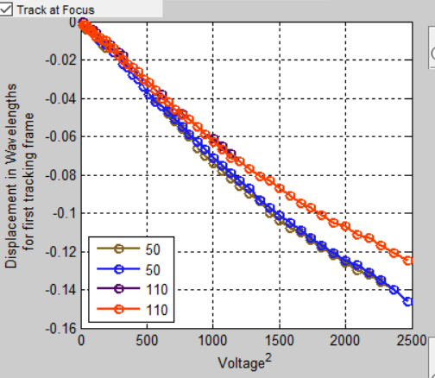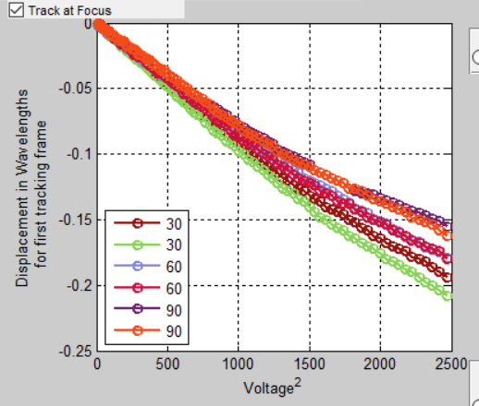

We expect to see a discontinuity in these curves when there is an equalization of pressure. At this stage we are not sure of exact pressure that is being created at the tube interface. For this we plan to design a new phantom with a hydrophone located at the level of the tube interface. This way we would be able to know the exact pressure being created at the tube.

**Plan for determination of $I$ at the tube interface**

Since we would be investigating either the carotid or the brachial artery, we need to characterize the attenuation that would be experienced by the ultrasound beam before reaching the arterial wall. This would determine the intensity at the arterial surface.

We can empirically determine the attenuation associated with typical muscle and fat layers in neck and arm. We do not expect these values to change too much between population. Such a characterization can be done by taking typical biological sections and measuring their attenuation per unit length. Once we have these values we can use them to determine the approximate $I$ for any other case.

Displacement of a tissue is proportional to the intensity [1]. We can use this concept for individual recalibration of the attenuation. We can move a section of the tissue away from the artery and compare the displacement with standard expected displacement. The deviation from standard value can be used to calibrate the attenuation for each patient.

**References**

[1] Nightingale, Kathryn R., et al. "On the feasibility of remote palpation using acoustic radiation force." *The Journal of the Acoustical Society of America* 110.1 (2001): 625-634.  
[2] Dumont, Douglas, et al. "Lower-limb vascular imaging with acoustic radiation force elastography: demonstration of in vivo feasibility." *IEEE transactions on ultrasonics, ferroelectrics, and frequency control* 56.5 (2009): 931-944.  
[3] D. Christensen, *Ultrasonic Bioinstrumentation* ~Wiley, New York, 1988.  
[4] G. Torr, Am. J. Phys. **52**, 402 ~1984.  
[5] Ryan, Linda K., and F. Stuart Foster. "Tissue equivalent vessel phantoms for intravascular ultrasound." *Ultrasound in medicine & biology* 23.2 (1997): 261-273.

We would look for the acoustic intensity required to produce an N microns shift in the arterial wall.

For the same temporal average intensity, a wave with higher pressure amplitude and shorter pulse duration generates a larger radiation force than does a lower amplitude, longer duration wave.

\*Idea 1: If the absorption between individuals vary only by about 5-10 percent then we should be able to empirically characterize the force and still get an error of less than 10% in pressure measurement.

Thin film force sensor

Scope for direct measurement of arterial stiffness.

What is the trajectory of return of the wall with respect to time. Is it different for different internal pressures?